TAGING
- Login as root user
Query:

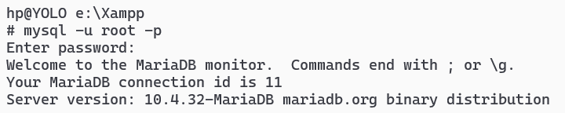
- Check all possible privileges
Query:

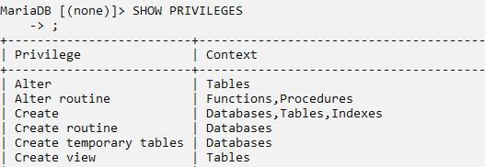
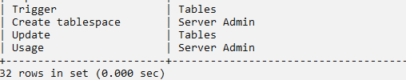
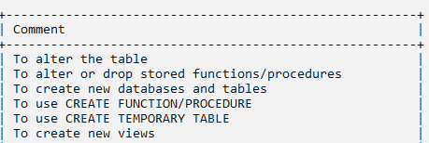

- List Existing Users of Mysql DBMS
a. SELECT USER,HOST FROM mysql.user;
Query:

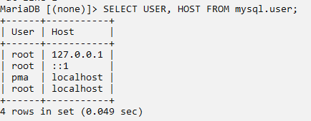
- Check privileges of existing user as
a. SHOW GRANTS FOR '<user>'@'localhost';
Query:

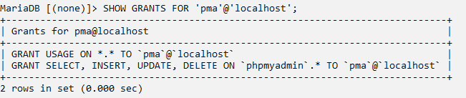

SETUP

- List all existing Database:
Query:

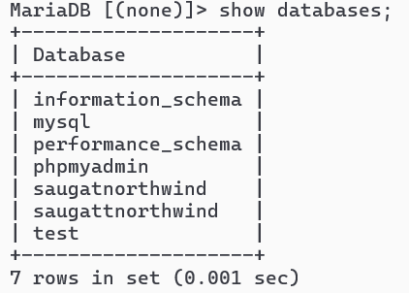
- Create a database <your-name>
Query:

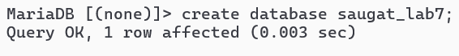
- Verify your database is created:
Query:

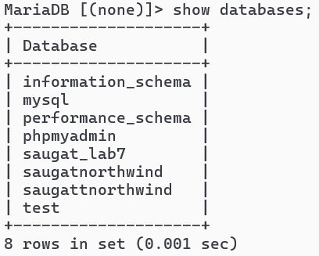
- Create a user <your-name>
Query:

- Exit current session
Query:

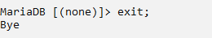
- Login as newly created user i.e. <yourname>
Query:

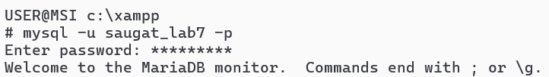
- Check databases and exit
Query:

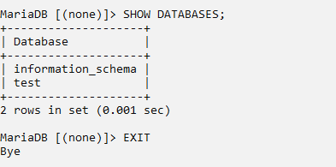
GRANT
- Login as root user
Query:

- GRANT Privileges to user <yourname> to existing databases and exit
Query:

Query:

- Login as <yourname> user
Query:

- Use database, CREATE table td1(id,name)
Query:

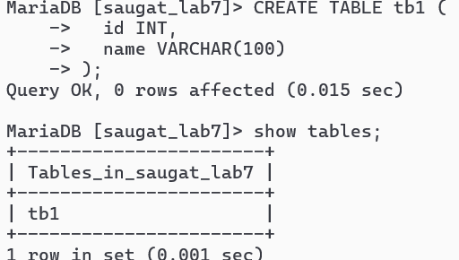
- INSERT 2 records, UPDATE 1 record, Delete 1 RECORD
Insert 2 records
Query:

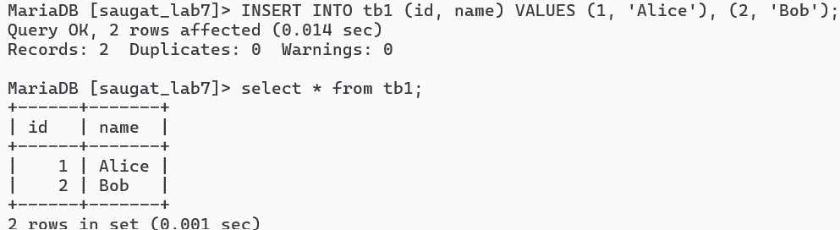
Update one record
Query:

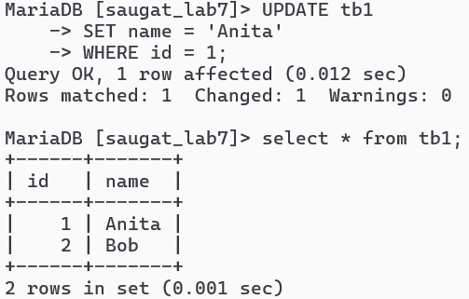
Delete one record
Query:

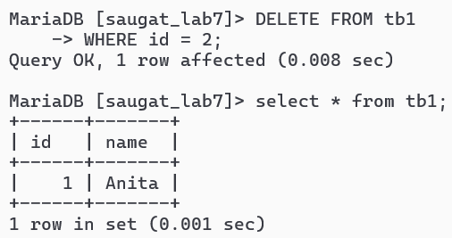
- Exit
Query:

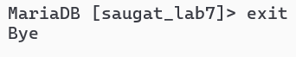
REVOKE:
- Login as root user
Query:

- REVOKE Privileges to user <yourname> to existing databases and exit
Query: RE
VOKE ALL PRIVILEGES ON rajesh.* FROM rajesh@localhost;

- Login as <yourname> user
Query:

- Check Databases
Query:

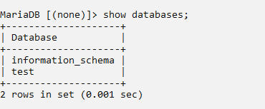
- Exit
Query:

